SUMMER CAMP PATROL DAILY ITEMS of INTEREST

- Campsite Inspections – Conducted each morning by SPL/ASPL

- Tent Flaps – Rolled inward and all alike

- Sleeping Bags – Folded in half on bunks

- Personal Gear – Properly stored under bunks

- Close Lines – Properly strung and utilized

- Ground Cover – NOT cleared away

- Pathways – May be indicated / outlined, and kept free of trash

- Fire Pits – Cleaned and remains free of trash

- Latrine – Cleaned each morning and throughout the day if necessary by
assigned patrol

- Common Areas (Tables, etc.) – Free of trash and personal gear

- Camp Notices (Bulletin Board) – Required camp information and troop’s daily schedule displayed

- Waiters (If required) – Everyone gets a chance to perform

- TLC Meetings – Short meeting conducted each evening to review past day’s
events and preview next day’s events

(OVER)
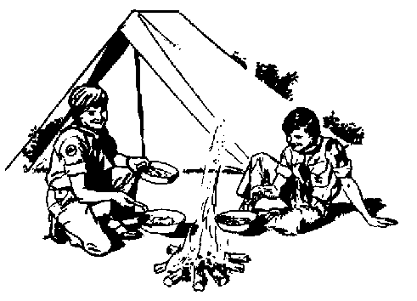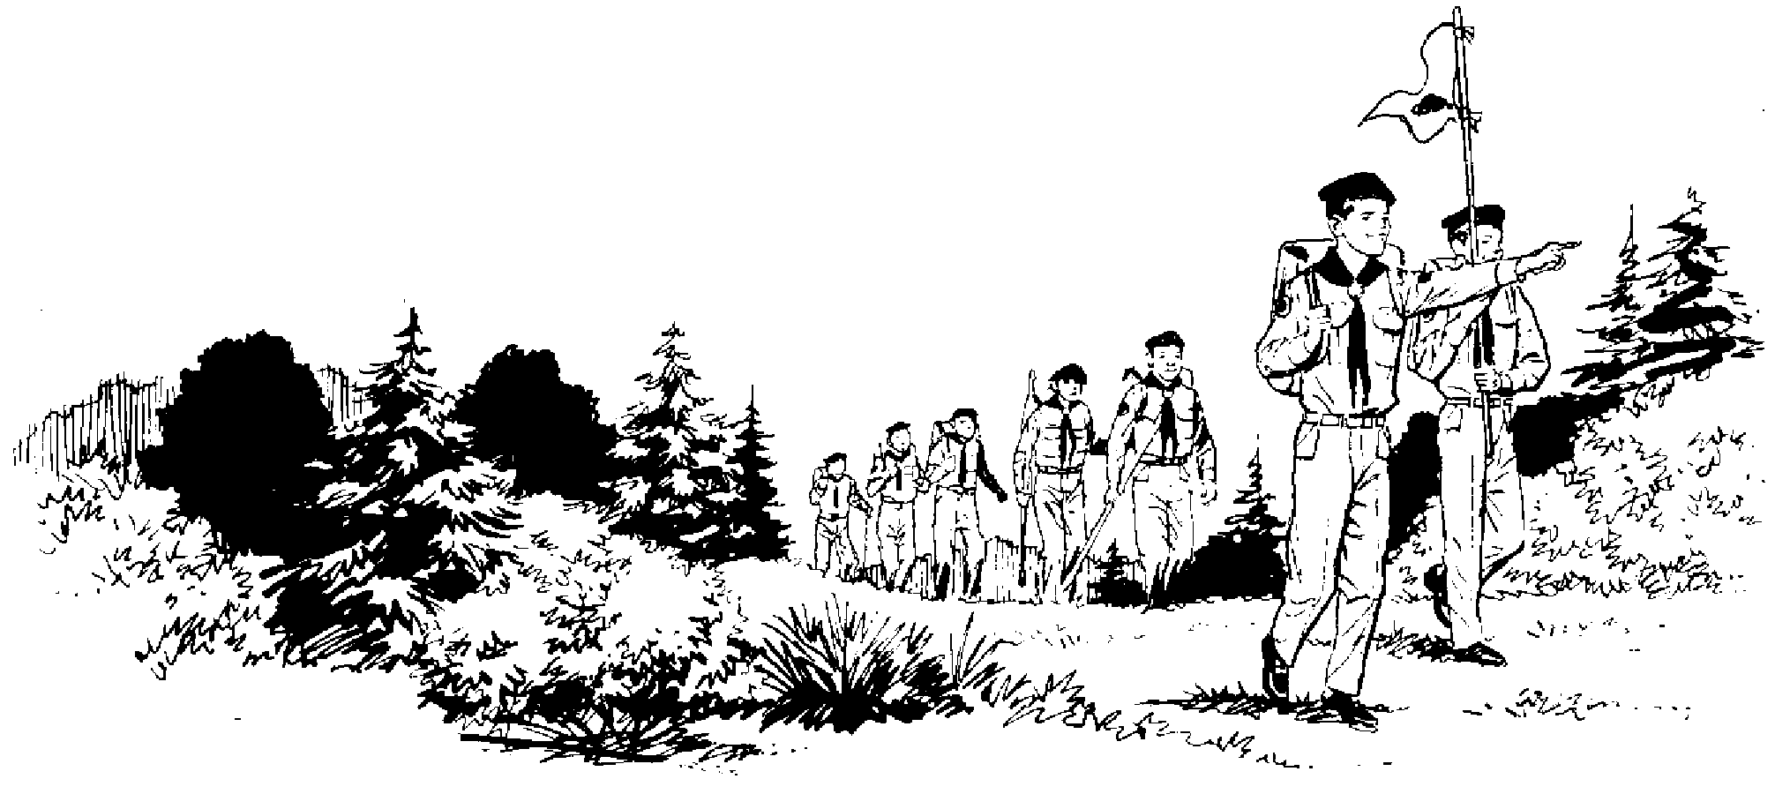

KEYS TO A SUCCESSFUL CAMPSITE INSPECTION

- Patrol members clean-up personal tent sites and common areas assigned (Latrine, Trails, Tables, etc.) immediately after reveille.

- Patrol Leader reports completion of clean-up to SPL Staff.

- SPL Staff verifies patrol inspection has been completed, notes any discrepancies, and ensures they are corrected.

- Once all patrols have reported to SPL Staff, and all discrepancies have been corrected, Patrols are released to Merit Badge Class.

- SPL reports to Scoutmaster who does a quick spot check and releases SPL Staff to attend Merit Badge Class.

- If scouts return to camp prior to campsite inspection by camp staff personnel they need to ensure that “Leave No Trace” is in force … at least until the inspection has been completed 😊.

Campsite reveille time can be adjusted based on the time necessary to complete the inspection and morning clean-up process. Hopefully it (at least it’s intended to) goes faster as the week progresses allowing for a later ‘awakening’ time 😊.

As B.S.A. has found evident over the years, uniformity is the key to any unit looking good. It’s also a way to judge a scout’s leadership ability in carrying out any given task. Again, the intent being the same standard is used repeatedly and improvement (hopefully) can be gaged as the week progresses.

